Aaron Price

Greg Rowland

Jani-Beth Outlaw

Jeff Soles

John Price

Shawn Wombles
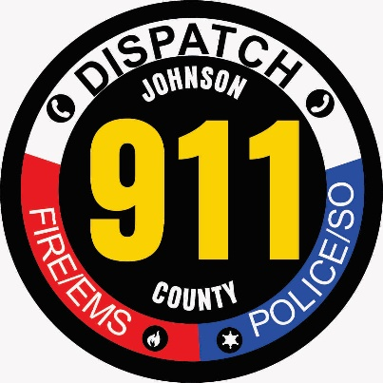

Bill Lindsey County Administrator

Joseph Carl Sumner Jr. County Attorney

JOHNSON COUNTY 911
Address Application

Date: ______________________ Parcel# ____________________

Road Name: ____________________________________________________________

Property Owner: _________________________________________________________

Phone Number: __________________________________________________________

Structure Type: House ____ Mobile Home____ Church _____ Business ____ Other ____

Please explain Other: _____________________________________________________

Directions: ______________________________________________________________

________________________________________________________________________

___________________________________________________________________________________________________________
Applicant’s Signature: _____________________________________________________

Johnson County 911 Signature: ______________________________________________

Official Use Only

Full Address: ____________________________________________________________

Received By: ____________________________________________________________

